**FEE TRANSMITTAL**

**Form PTO/SB/17**



**Applicant:** Brian James Rutherford

**Docket Number:** RUTHERFORD-013_PROV

**Title of Invention:**

Federated Quantum Threat Intelligence Network with Privacy-Preserving Multi-Organization Protocols, Zero Trust Architecture, Quantum-Verified Incident Response with Optimized Latency, and Quantum Homomorphic Encryption

**First Named Inventor:** Brian James Rutherford

**Filing Date:** [TO BE ASSIGNED]

**Examiner:** [TO BE ASSIGNED]

**Art Unit:** [TO BE ASSIGNED]



**FEE CALCULATION**

|  |  |  |  |  |  |  |
| --- | --- | --- | --- | --- | --- | --- |
|  | **Fee Code** | **Description** | **Micro Entity Fee** | **Quantity** | **Fee Subtotal** | |
| 1021 | | Basic Filing Fee - Provisional | $75.00 | 1 | $75.00 |  |
|  |  |  |  | **TOTAL:** | **$75.00** |  |
|  |  |  |  |  |  |  |
|  |  |  |  |  |  |  |

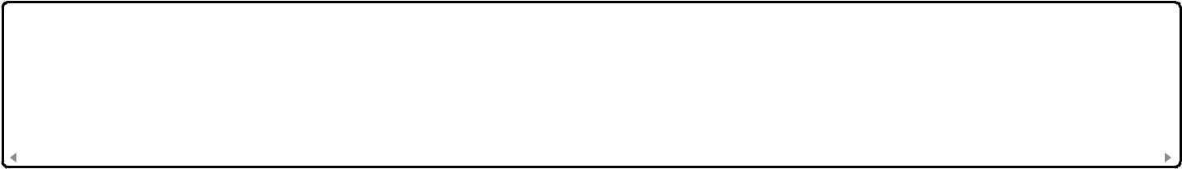

**APPLICANT CLAIMS MICRO ENTITY STATUS**

* Small Entity Status
* Large Entity
* **Micro Entity Status Verified**



**METHOD OF PAYMENT**

* Check
* Money Order
* **Credit Card via EFS-Web**

☐ Deposit Account

☐ USPTO Patent Fee Deposit Account Number: ___________



**CREDIT CARD AUTHORIZATION**

**For EFS-Web Electronic Payment:**

The USPTO is hereby authorized to charge the above-listed fees totaling **$75.00** to the credit card provided through the EFS-Web electronic filing system.



**ADDITIONAL FEES**

* Additional fees are required (see continuation sheet)

☒ **No additional fees are required**



**CORRESPONDENCE**

Please send correspondence to:

**Brian James Rutherford**

6 Country Place Drive

Wimberley, TX 78676-3114

Tel: (512) 648-0219

Email: [Actual@ScrappinR.com](mailto:Actual@ScrappinR.com)



**SIGNATURE**

**Signature:** /Brian James Rutherford/

**Name:** Brian James Rutherford

**Title:** Inventor/Applicant Pro Se

**Date:** [CURRENT DATE]

**Telephone:** (512) 648-0219



**WARNING**

Any false statement or representation regarding small entity status is punishable under 18 U.S.C. 1001 and may jeopardize the validity of the application or any patent issuing thereon.



**END OF FEE TRANSMITTAL FORM**